Designing Forms and HTML

Exercise-1
Q1: Purpose of the ACTION and METHOD attributes in HTML forms
- ACTION: Specifies the URL or endpoint where the form data will be sent upon submission.
- METHOD: Defines how the data is transmitted. Common values include GET and POST.
Q2: Difference between GET and POST methods
- GET:
  - Appends form data to the URL as query parameters.
  - Suitable for small, non-sensitive data.
  - Not secure as data is visible in the URL.
- POST:
  - Sends form data in the request body.
  - More secure and supports larger data payloads.
  - Preferred for sensitive operations such as login or registration.
Q3: Common HTML form controls
- Textbox (<input type="text">)
- Password field (<input type="password">)
- Radio button (<input type="radio">)
- Checkbox (<input type="checkbox">)
- Dropdown (<select>)
- Textarea (<textarea>)
- Submit button (<input type="submit">)

Exercise 2 – MVC Application: Restaurants and Reviews

Model Class
File: Models/Restaurants.cs
namespace Week9tut.Models
{
public class Restaurants
{
public int Id { get; set; }
public string RestaurantName { get; set; }
public string RestaurantReview { get; set; }
}
}

Database Context
File: Models/Week9tutContext.cs
using System.Data.Entity;

namespace Week9tut.Models
{
public class Week9tutContext : DbContext
{
public DbSet<Restaurants> Restaurants { get; set; }
}
}

RestaurantsController
Controller name: RestaurantsController
using System;
using System.Collections.Generic;
using System.Data.Entity;
using System.Linq;
using System.Net;
using System.Web;
using System.Web.Mvc;
using Week9tut.Models; // Correct namespace for accessing the context

namespace Week9tut.Controllers
{
public class RestaurantsController : Controller
{
private Week9tutContext db = new Week9tutContext();

// GET: Restaurants
public ActionResult Index()
{
return View(db.Restaurants.ToList());
}

// GET: Restaurants/Details/5
public ActionResult Details(int? id)
{
if (id == null)
{
return new HttpStatusCodeResult(HttpStatusCode.BadRequest);
}
Restaurants restaurants = db.Restaurants.Find(id);
if (restaurants == null)
{
return HttpNotFound();
}
return View(restaurants);
}

// GET: Restaurants/Search
public ActionResult Search(string resname)
{
var resresult = db.Restaurants
.Where(r => r.RestaurantName.Contains(resname))
.ToList();

return View(resresult); // Search result will be shown in Search.cshtml
}

// GET: Restaurants/Create
public ActionResult Create()
{
return View();
}

// POST: Restaurants/Create
[HttpPost]
[ValidateAntiForgeryToken]
public ActionResult Create([Bind(Include = "Id,RestaurantName,RestaurantReview")] Restaurants restaurants)
{
if (ModelState.IsValid)
{
db.Restaurants.Add(restaurants);
db.SaveChanges();
return RedirectToAction("Index");
}

return View(restaurants);
}

// GET: Restaurants/Edit/5
public ActionResult Edit(int? id)
{
if (id == null)
{
return new HttpStatusCodeResult(HttpStatusCode.BadRequest);
}
Restaurants restaurants = db.Restaurants.Find(id);
if (restaurants == null)
{
return HttpNotFound();
}
return View(restaurants);
}

// POST: Restaurants/Edit/5
[HttpPost]
[ValidateAntiForgeryToken]
public ActionResult Edit([Bind(Include = "Id,RestaurantName,RestaurantReview")] Restaurants restaurants)
{
if (ModelState.IsValid)
{
db.Entry(restaurants).State = EntityState.Modified;
db.SaveChanges();
return RedirectToAction("Index");
}
return View(restaurants);
}

// GET: Restaurants/Delete/5
public ActionResult Delete(int? id)
{
if (id == null)
{
return new HttpStatusCodeResult(HttpStatusCode.BadRequest);
}
Restaurants restaurants = db.Restaurants.Find(id);
if (restaurants == null)
{
return HttpNotFound();
}
return View(restaurants);
}

// POST: Restaurants/Delete/5
[HttpPost, ActionName("Delete")]
[ValidateAntiForgeryToken]
public ActionResult DeleteConfirmed(int id)
{
Restaurants restaurants = db.Restaurants.Find(id);
db.Restaurants.Remove(restaurants);
db.SaveChanges();
return RedirectToAction("Index");
}

protected override void Dispose(bool disposing)
{
if (disposing)
{
db.Dispose();
}
base.Dispose(disposing);
}
}
}

Output:

Server:

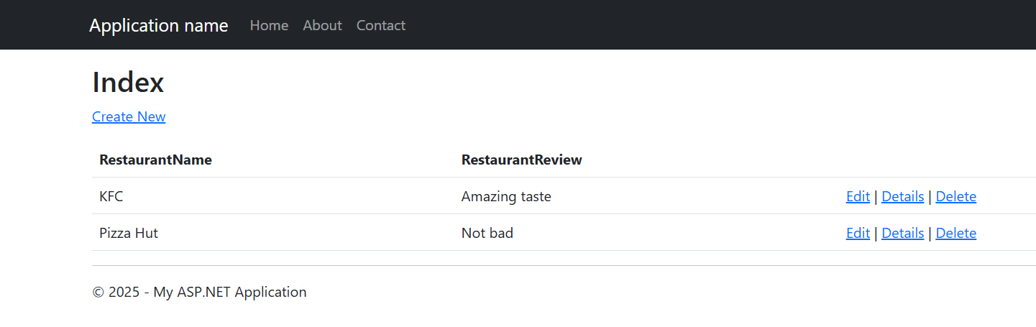

Database

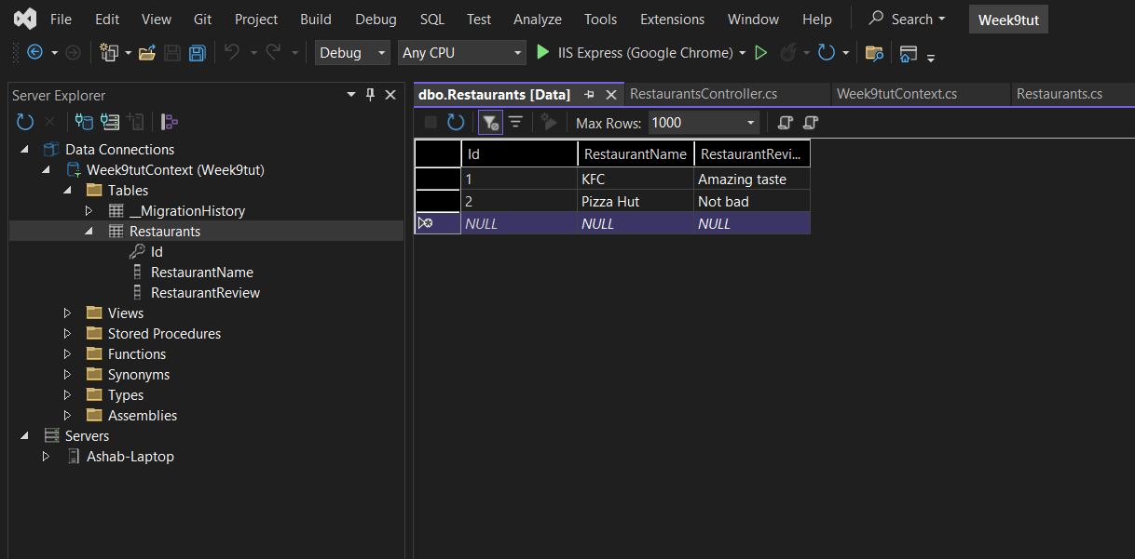

Exercise 3 – Search Tool for Restaurants

Search Box in Index View
File: Views/Restaurants/Index.cshtml
<form action="/restaurants/Search" method="get">
<label>Search restaurants by name</label>
<input type="text" name="resname" />
<input type="submit" value="Search" />
</form>

@model IEnumerable<Week9tut.Models.Restaurants>

@{
ViewBag.Title = "Index";
}

<h2>Index</h2>

<p>
@Html.ActionLink("Create New", "Create")
</p>

<table class="table">
<tr>
<th>
@Html.DisplayNameFor(model => model.RestaurantName)
</th>
<th>
@Html.DisplayNameFor(model => model.RestaurantReview)
</th>
<th></th>
</tr>

@foreach (var item in Model)
{
<tr>
<td>
@Html.DisplayFor(modelItem => item.RestaurantName)
</td>
<td>
@Html.DisplayFor(modelItem => item.RestaurantReview)
</td>
<td>
@Html.ActionLink("Edit", "Edit", new { id = item.Id }) |
@Html.ActionLink("Details", "Details", new { id = item.Id }) |
@Html.ActionLink("Delete", "Delete", new { id = item.Id })
</td>
</tr>
}
</table>

Controller Action
File: Controllers/RestaurantsController.cs
public ActionResult Search(string resname)
{
var result = db.Restaurants
.Where(r => r.RestaurantName.Contains(resname))
.ToList();
return View(result);
}

Search View
File: Views/Restaurants/Search.cshtml
@model IEnumerable<Week9tut.Models.Restaurants>

@{
ViewBag.Title = "Search";
}

<h2>Search Results</h2>

<table class="table">
<tr>
<th>Name</th>
<th>Review</th>
</tr>

@foreach (var item in Model)
{
<tr>
<td>@item.RestaurantName</td>
<td>@item.RestaurantReview</td>
</tr>
}
</table>

Output:
Add Search Box

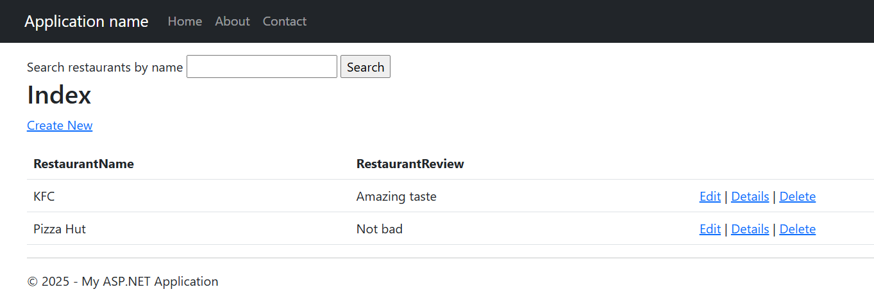

Search restaurants by name

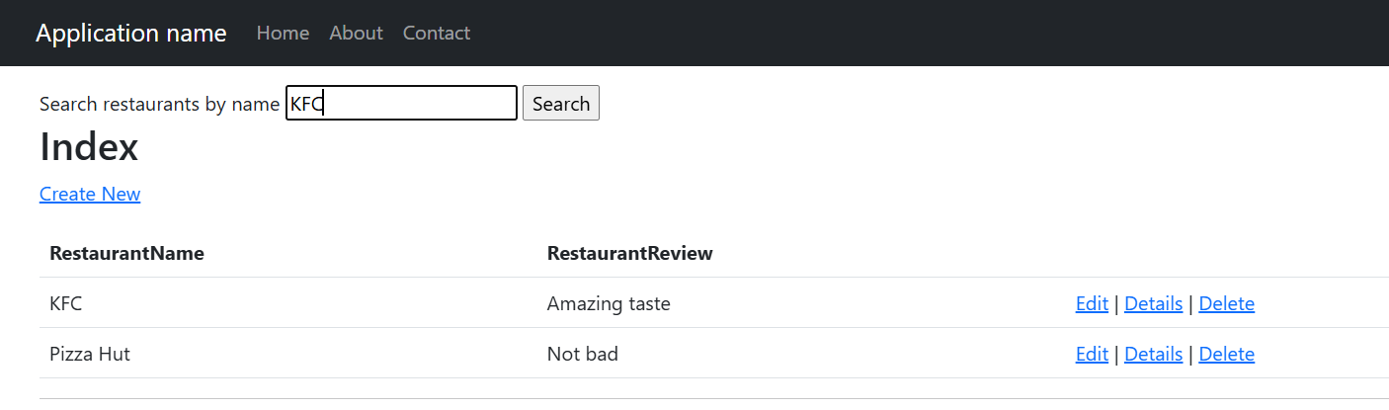

Show Search Results

